

USE CASES, USER STORIES, SSDs & DOMAIN MODEL FOR
ENVIRONMENTAL ACTIVITIES MONITORING PLATFORM

TEAM MEMBERS:
MUHAMMAD ABUZAR JAVED
QASIM ALI

SUPERVISED BY:
DR. ONAIZA MAQBOOL
DEPARTMENT OF COMPUTER SCIENCE
QUAID-I-AZAM UNIVERSITY, ISLAMABAD

The Use Case 1: “Create Activity” (Abuzar)
- Actor: Area Organizer
- Pre-condition: The user is logged in on the platform and is the Area Organizer of an area/group.
- Post-condition: Platform shows the newly added activity, users receive an alert about the action, and users can view it.
- Main Success Scenario:
  - User selects the area/group in which he/she wants to create new activity.
  - User clicks "Create Activity" button given in the selected area/group.
  - The system displays the input fields to get input data.
  - User inputs the required data in the fields.
  - User clicks “Confirm Creation” button.
  - The system checks the data and saves it into the database.
  - The system displays the success message for the action.
  - User sees the new added activity in that area/group.
- Alternative Flows:
  - Alt Flow A: User abort the the creation action and instead of clicking “Confirm Creation”, he/she clicks “Cancel” button.
- Exception Flows:
  - Exception 1: The data input in the fields by user is invalid or validation checks fail, then the system won’t add data and won’t create the activity.

User Stories

User Story 1 (Priority: High)
As an Area Organizer, I want that when I create a new activity, the system must send an alert to all the members so that they get informed about the action.
Acceptance Criteria:
- The system must notify the area members about the activity.
- The app icon and notification bar must show the notification bubble.

User Story 2 (Priority: High)
As an Area Organizer, while creating an activity, I want to add comprehensive details about the activity, so that I can make sure it is interpreted correctly.
Acceptance Criteria:
- The system’s data input fields should be so that I can add comprehensive details about the activity.
- The labels for input fields must be unambiguous so that it is easy to understand what an input field is for.

System Sequence Diagram

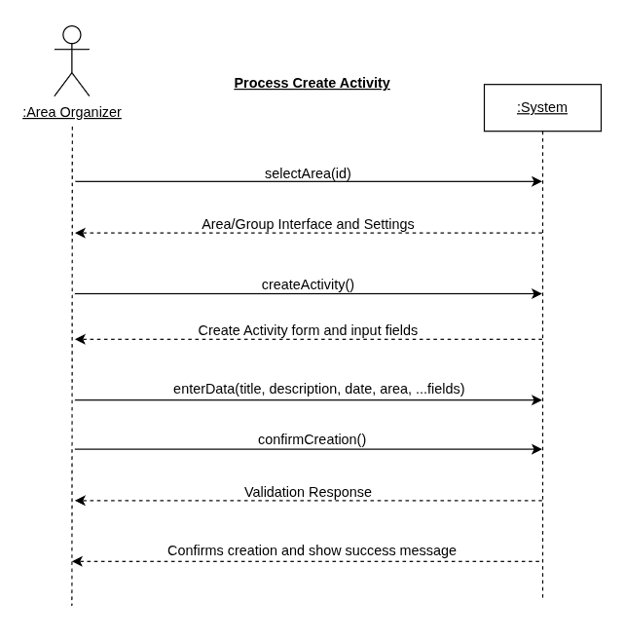

The Use Case 2: “Join Area” (Qasim Ali)
- Actor: Area Member
- Pre-condition: The user is logged in on the platform.
- Post-condition: The system shows the newly added Area Member.
- Main Success Scenario:
  - The user chooses the area to be joined.
  - The user clicks the "Join Area" button in the chosen area.
  - The system displays the input fields to get the input data.
  - The user inputs the data in the fields.
  - The user clicks the “Confirm Joining” button.
  - The system checks the data and saves it into the database.
  - The system displays the success message for the joining.
  - The system displays the newly added Area Member in the area.
- Alternative Flows:
  - Alt Flow A: The user cancels joining the area by clicking the “Cancel Joining” button instead of the “Confirm Joining” button.
  - Alt Flow B: The user is already an Area Member of the area and the system clears all the input fields, showing “Already an Area Member!”.
- Exception Flows:
  - Exception 1: The data input by the user is invalid or the validation checks fail and the system won’t add the data and won’t add the user as an Area Member of the area.

User Stories

User Story 1 (Priority: High)
As an Area Member, while joining an area, the system must provide information about the area and its management-related status.
Acceptance Criteria:
- The system must provide relevant information about the area.
- The system must provide the management-related matters in the area.
- The system must identify the Area Organizer of the area.

User Story 2 (Priority: High)
As an Area Member, while joining an area, the system must provide the rules and guidelines related to the membership of the area.
Acceptance Criteria:
- The system must mention the rules and guidelines right after choosing an area.
- The system must provide the rules and guidelines in a clear and understandable format.

System Sequence Diagram

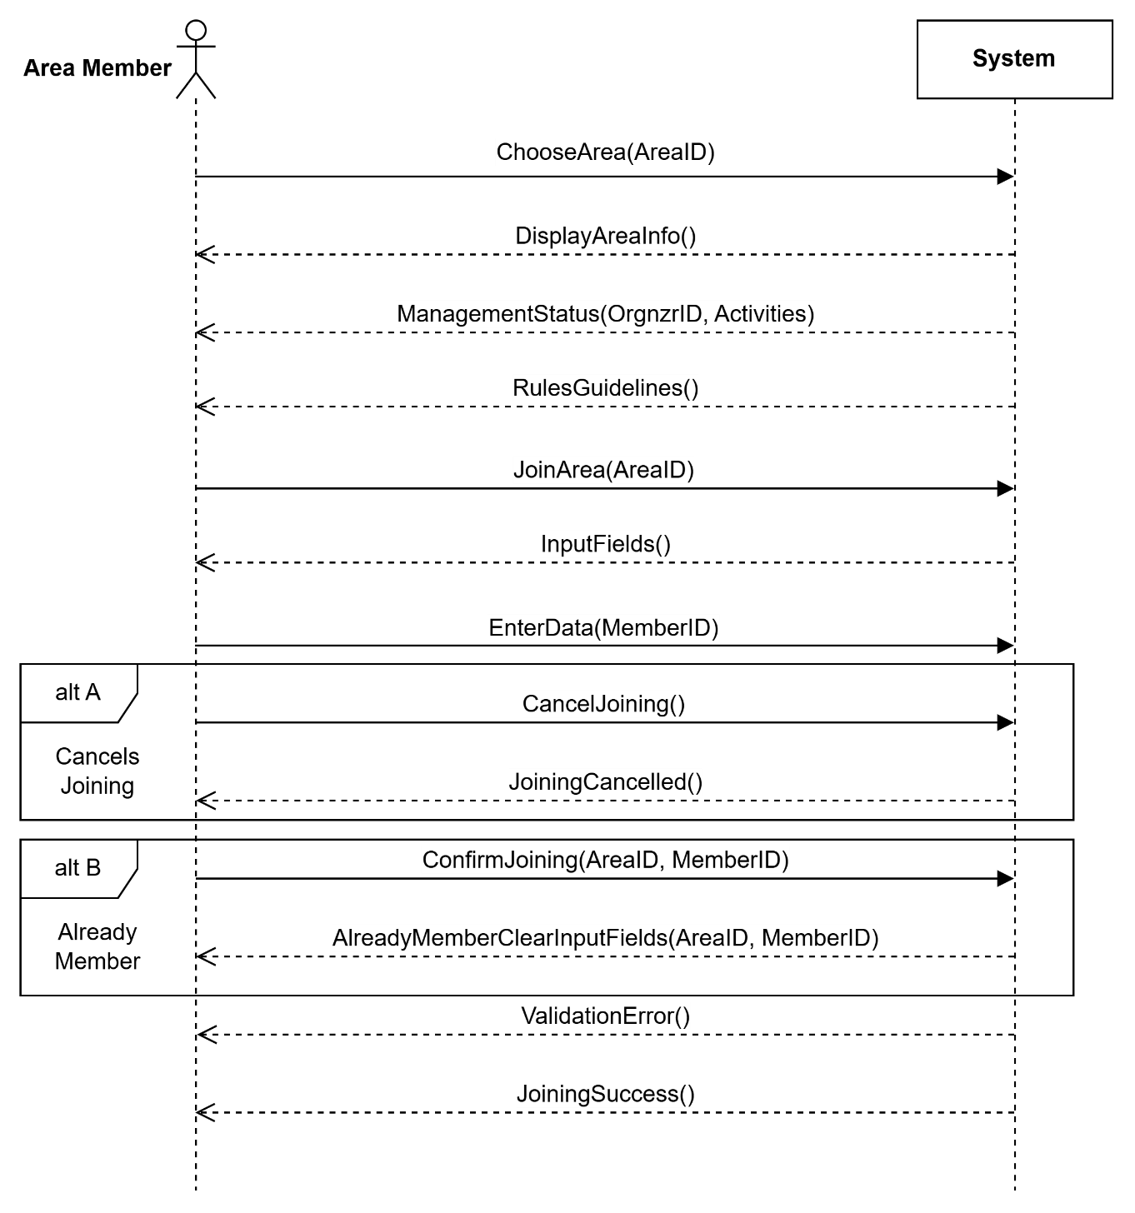

The Domain Model

